**Project No: 1**

##### Project Title: Blood Donation Project Description:

Blood Donation site contains information about the number of blood banks and applicants willing to Donate blood.

It should covers the following modules:

##### Register, Why to donate blood, who can give blood, Refer a friend, Contact us

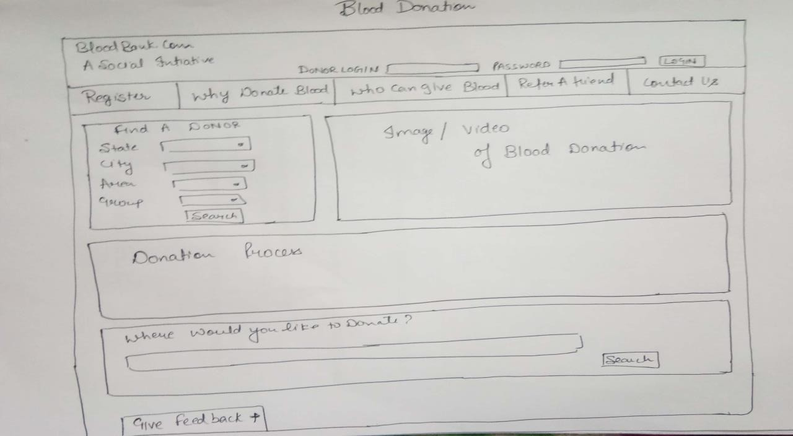

**Project No: 2**

##### Project Title: Restaurant

**Project Description:** It should covers the following modules:

##### Home, About us, Menu, Gallery, Healthy tips, Contact us

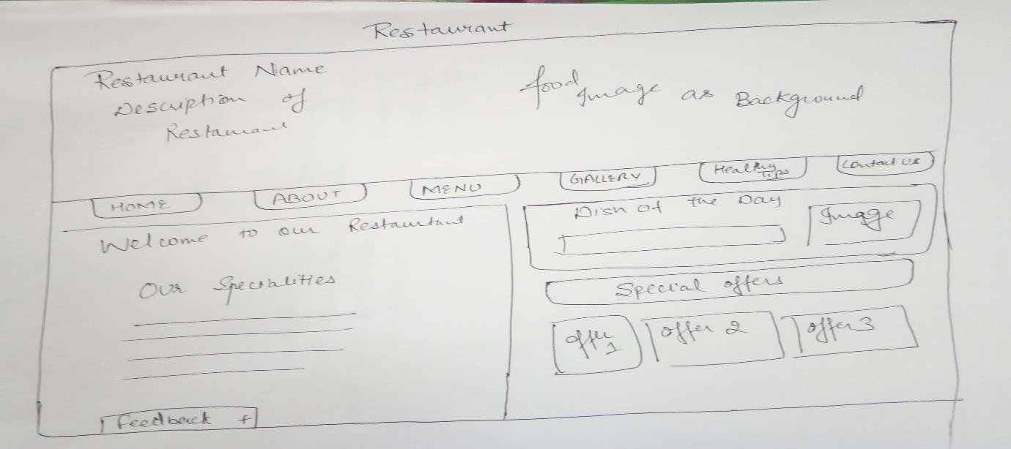

**Project No: 3**

### Project Title: Property Website

**Project Description:** It should covers the following modules:

##### Buy, Rent, Sell, Contact us, Sign up

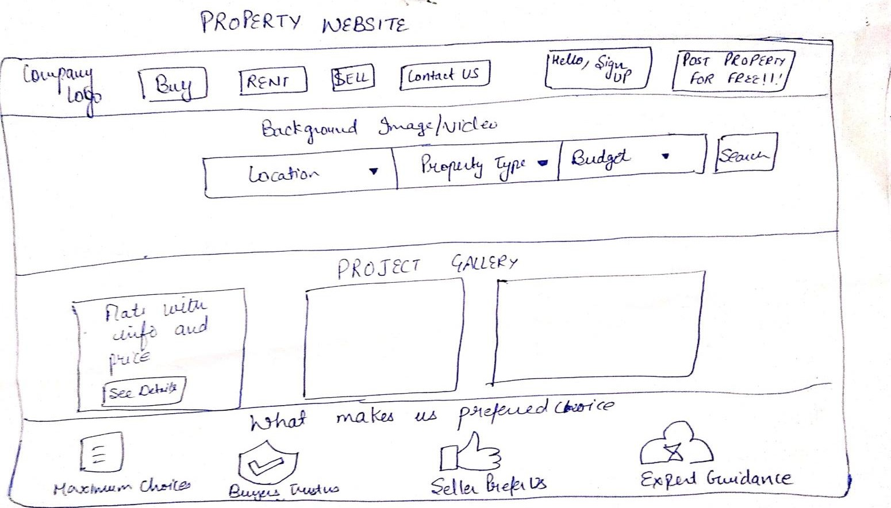

**Project No: 4**

### Project Title: Car Rental System

**Project Description:** It should include the following modules

##### Sign up, login, manage booking, popular locations

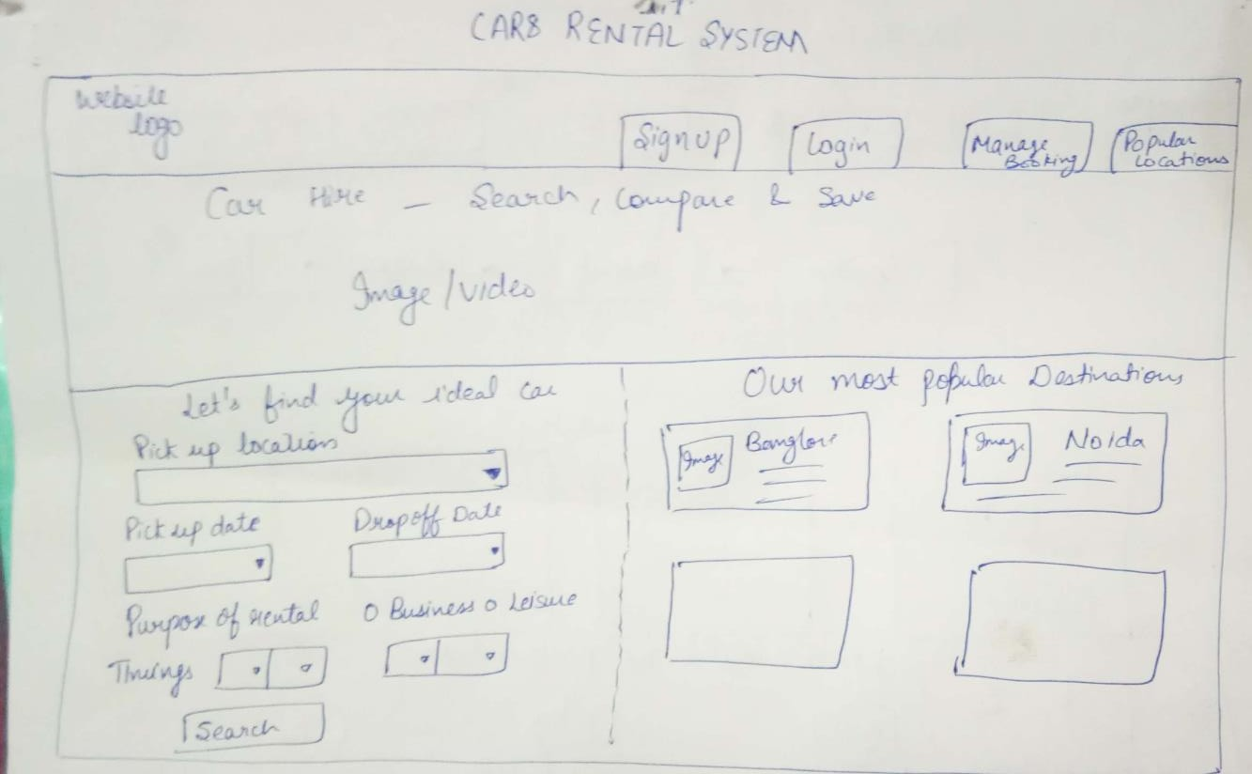

**Project No: 5**

### Project Title: Grocery website

**Project Description:** It should include the following modules

##### Revolution, products, advantages, contact us

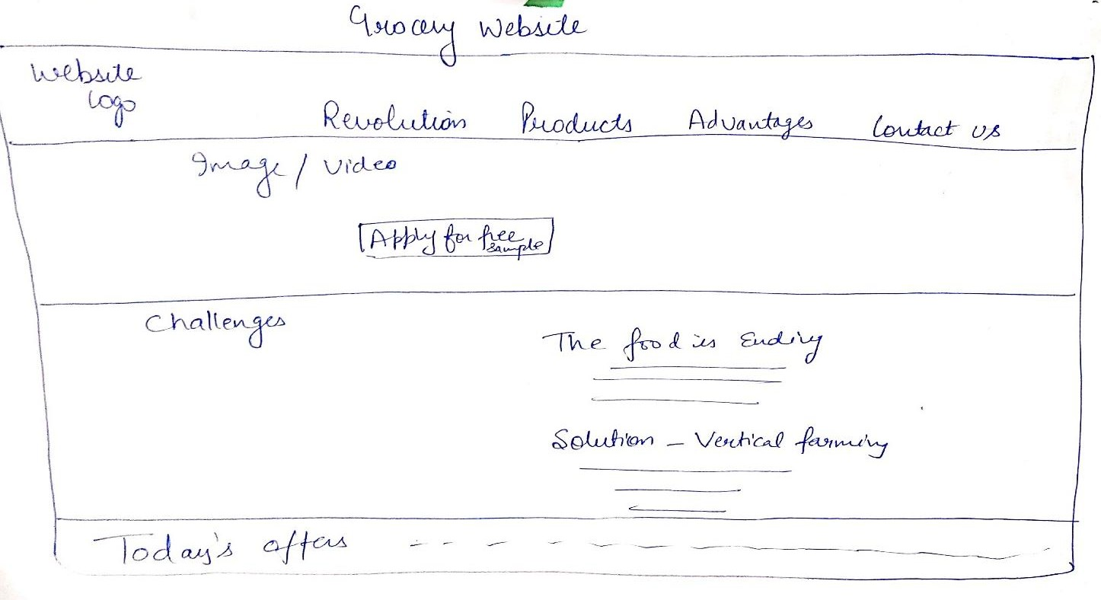

**Project No: 6**

### Project Title: Fitness Club

**Project Description:** It should include the following modules

##### About us, trainings, timetable, nutrition, gallery

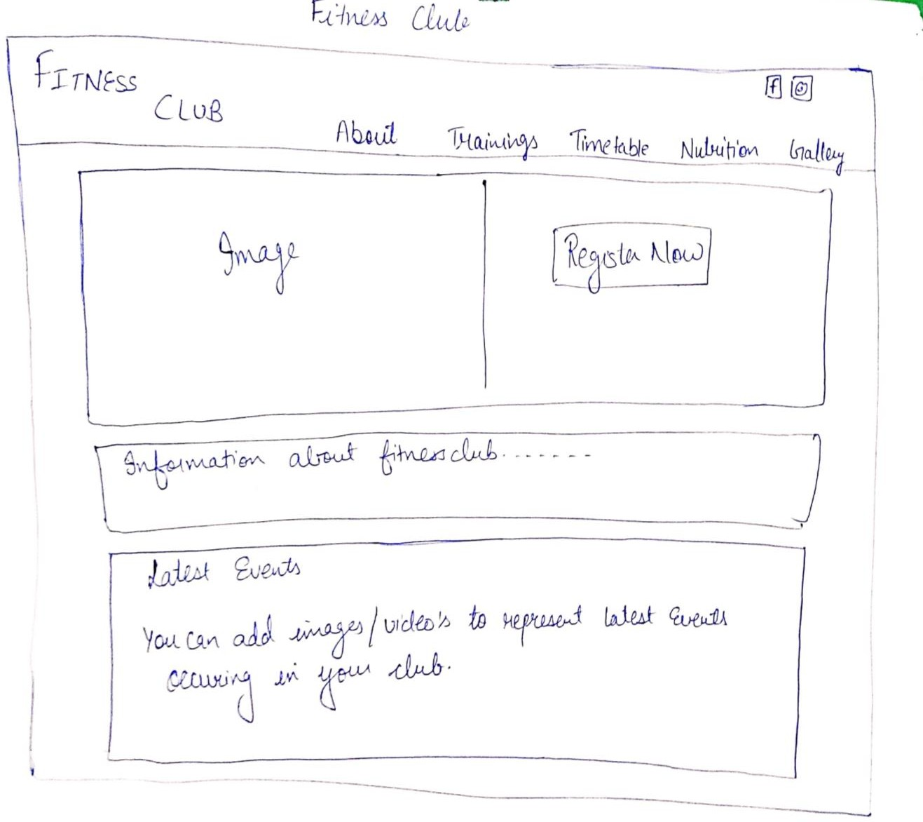

**Project No: 7**

### Project Title: Railway Reservation System

**Project Description:** It should include the following modules

##### Home, Meals, Holiday Packages, Service at station, Contact us

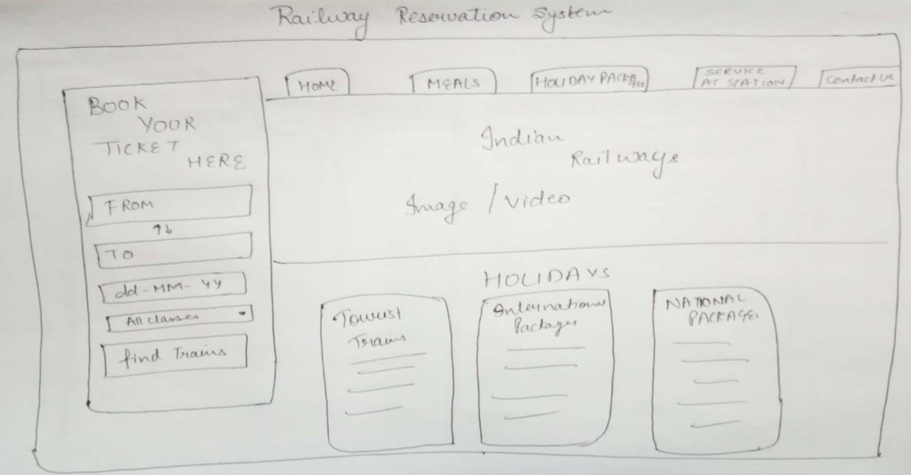

**Project No: 8**

### Project Title: Learning System

**Project Description:** It should include the following modules

##### Videos, Tutors, test yourself, contact us, topics

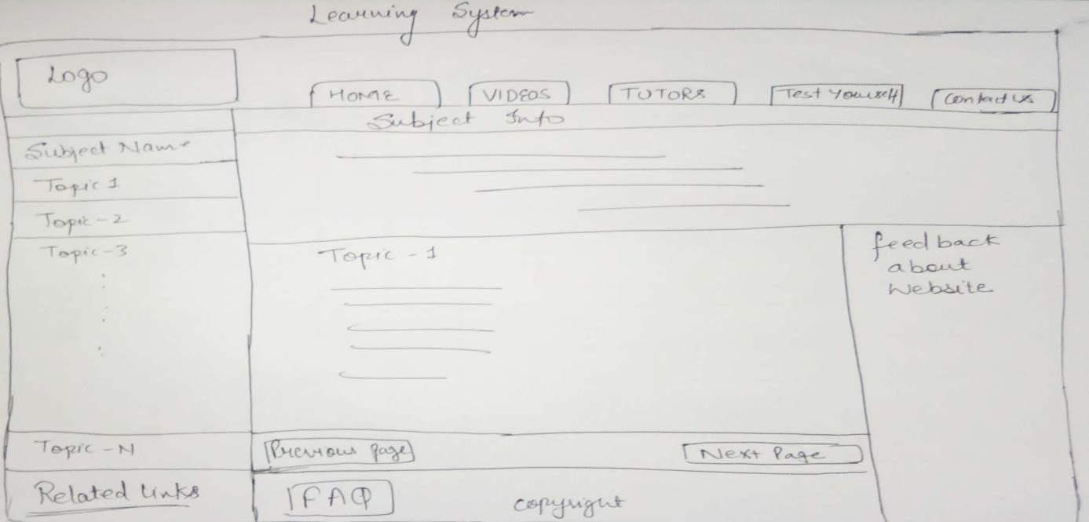

**Project No: 9**

### Project Title: University Management System

**Project Description:** It should include the following modules

##### Home, timetable, examination, change password, login

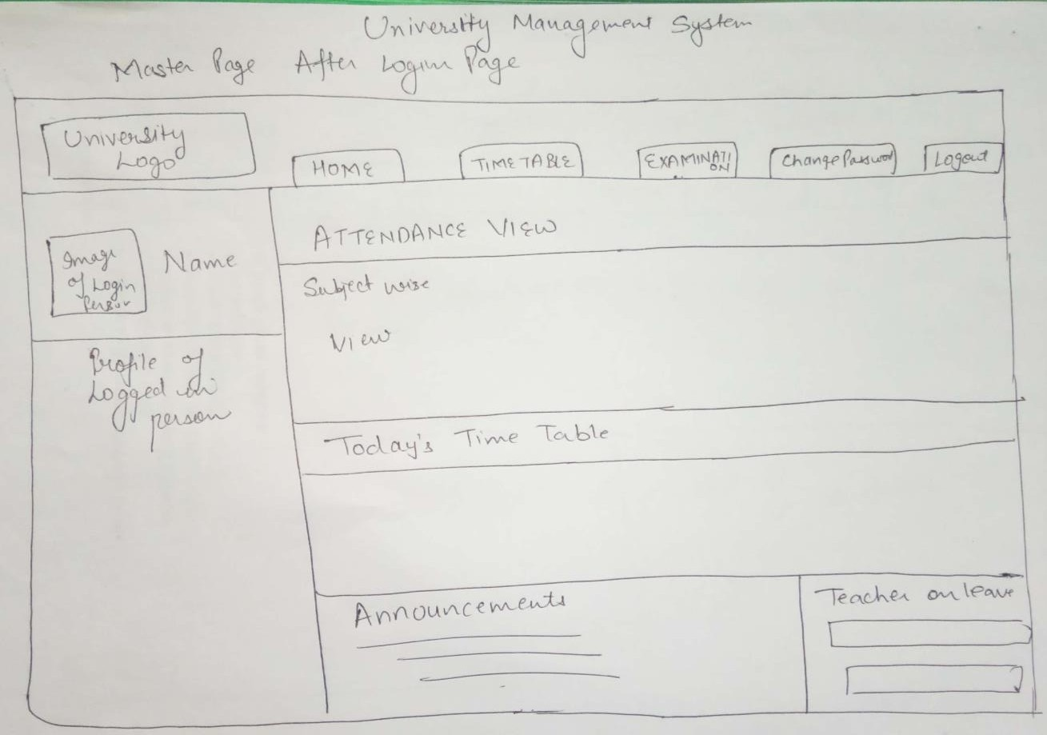

**Project No: 10**

### Project Title: Construction website

**Project Description:** It should include the following modules

##### Home, About us/ history, our business, projects, media, career, contact us

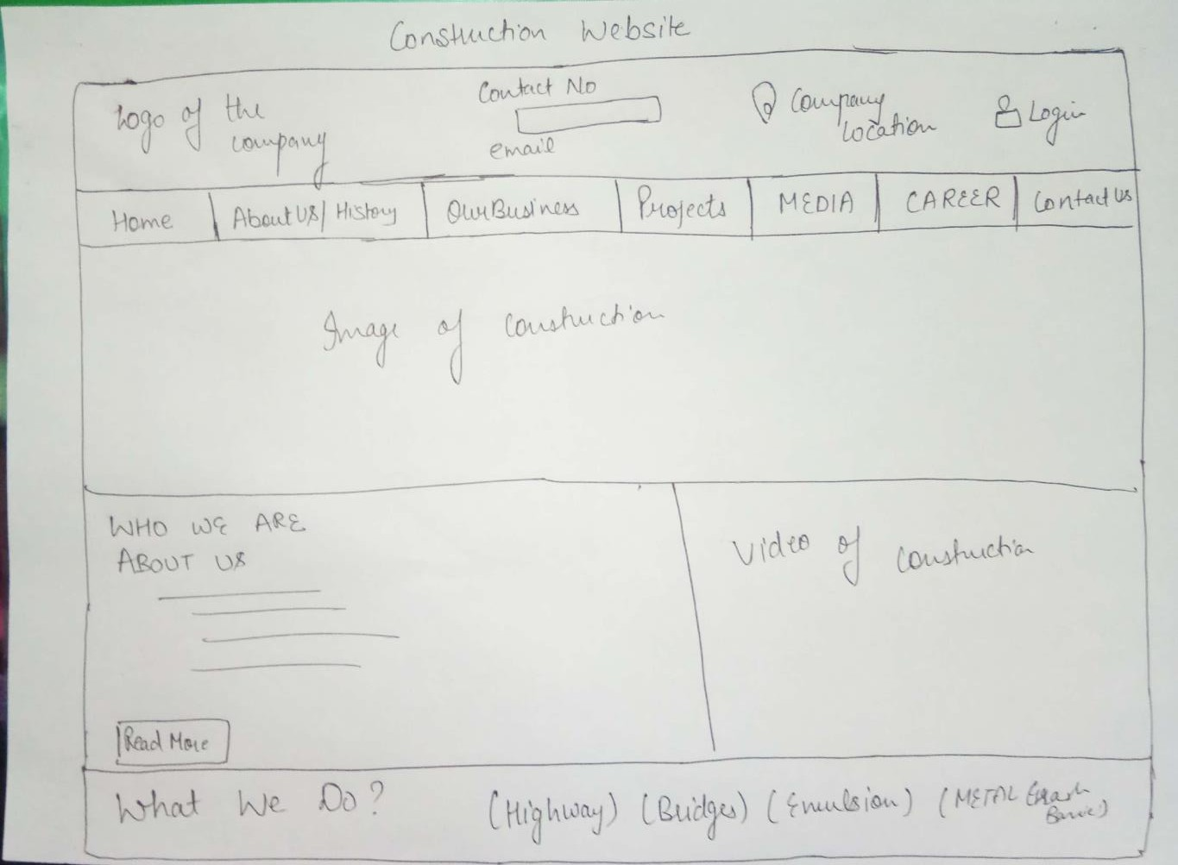

**Project no.11**

**Marketing Website**

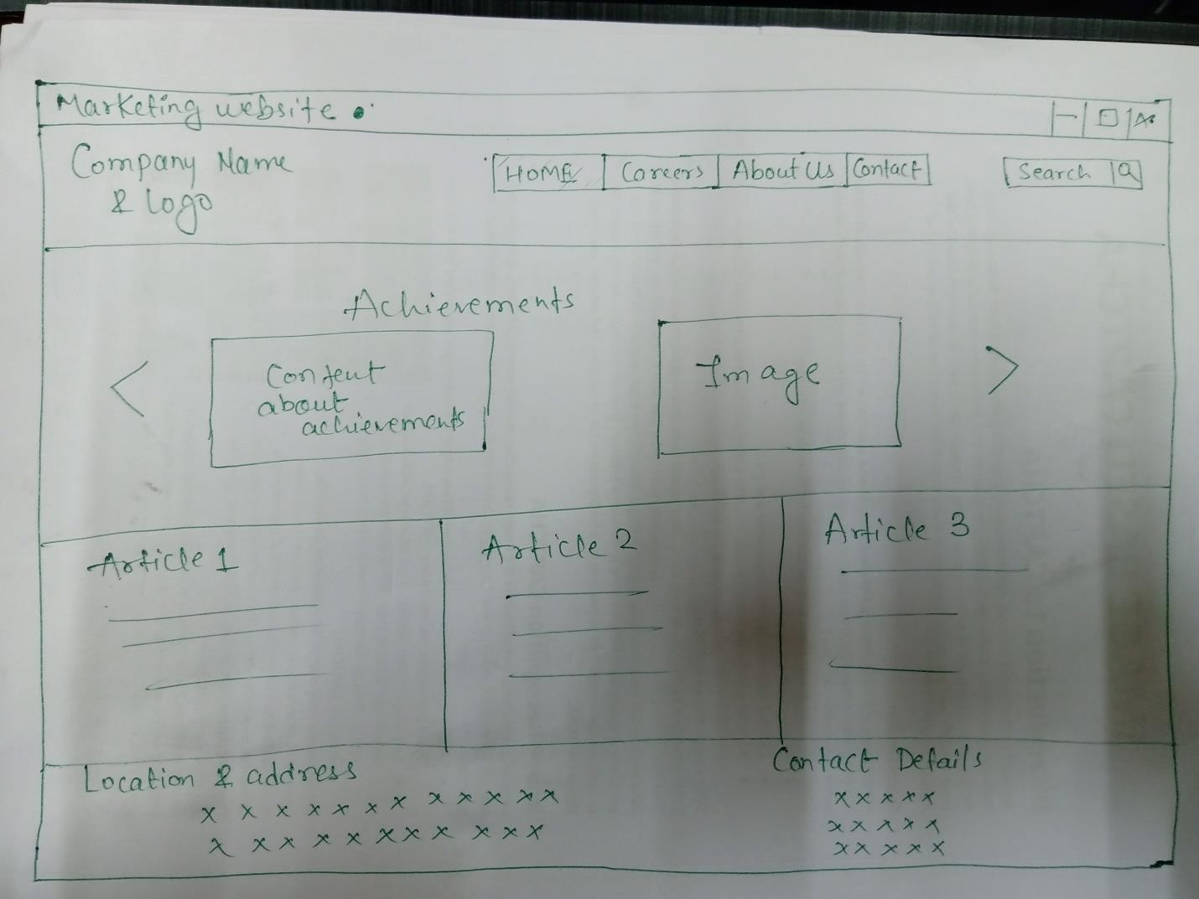

**Project no. 12 Educational Website**

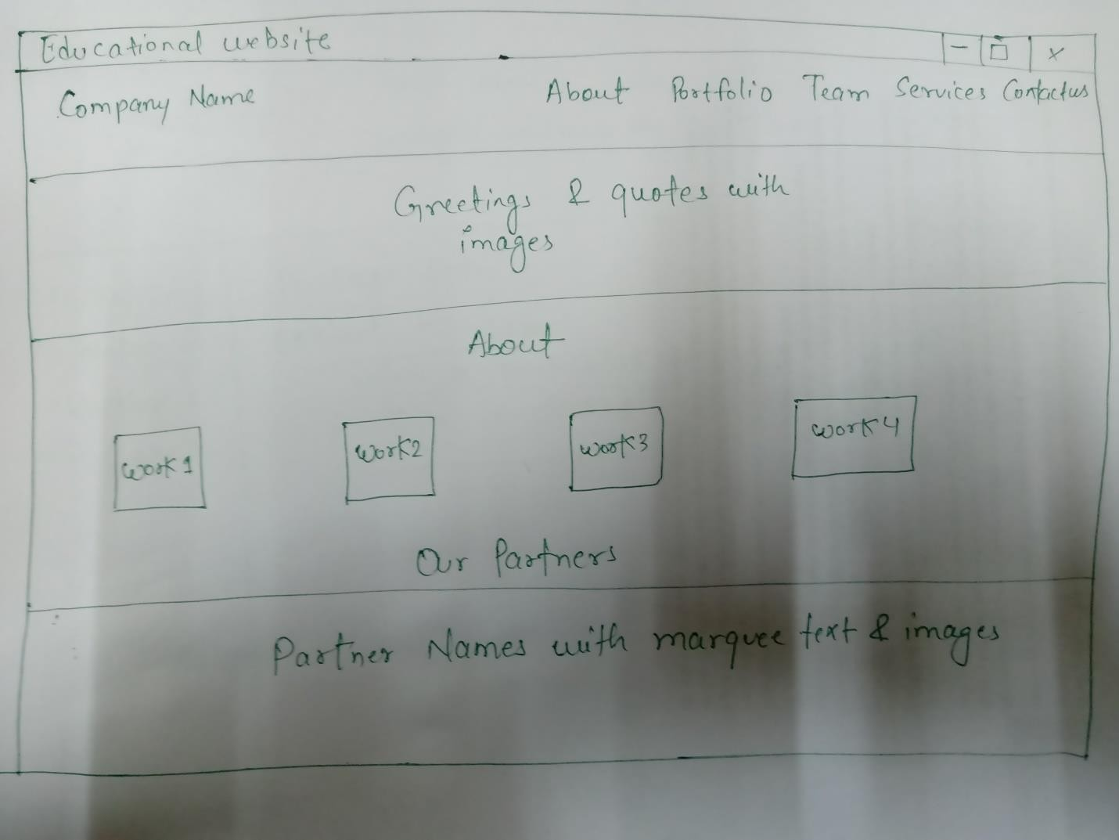

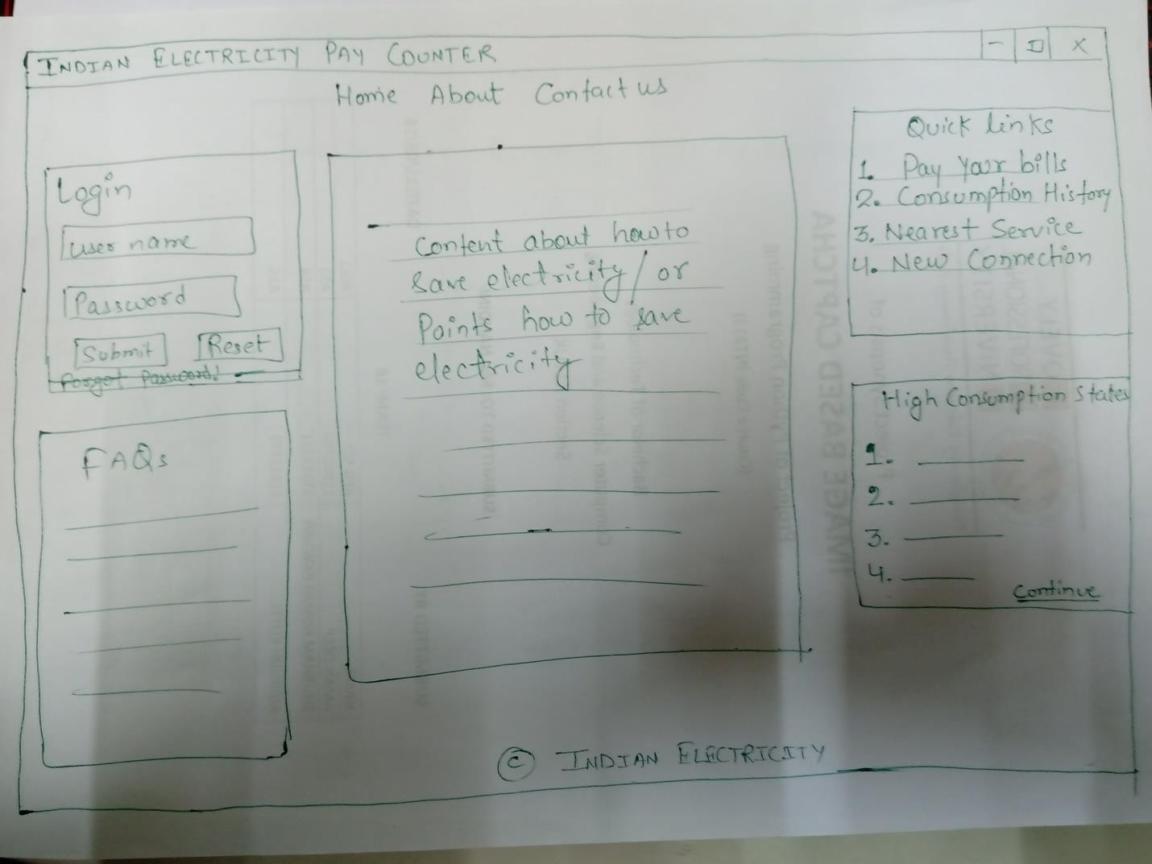

Project 13 **Indian Electricity Website**

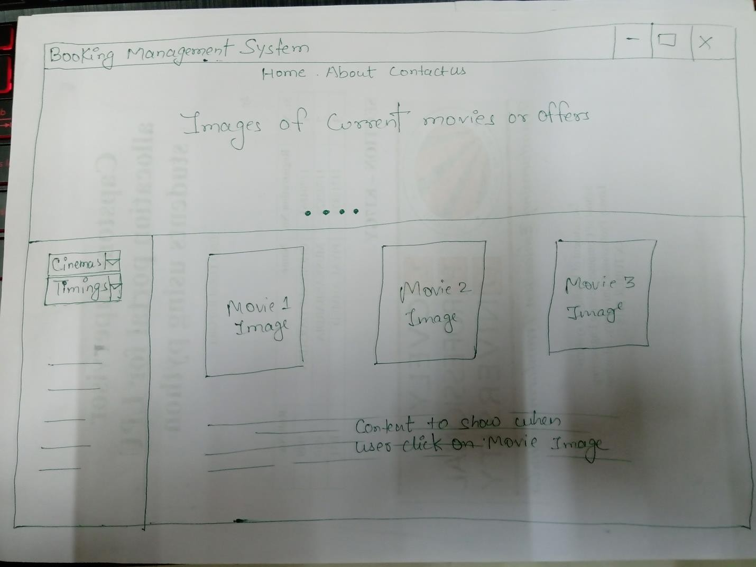

Project 14 **Booking management System**

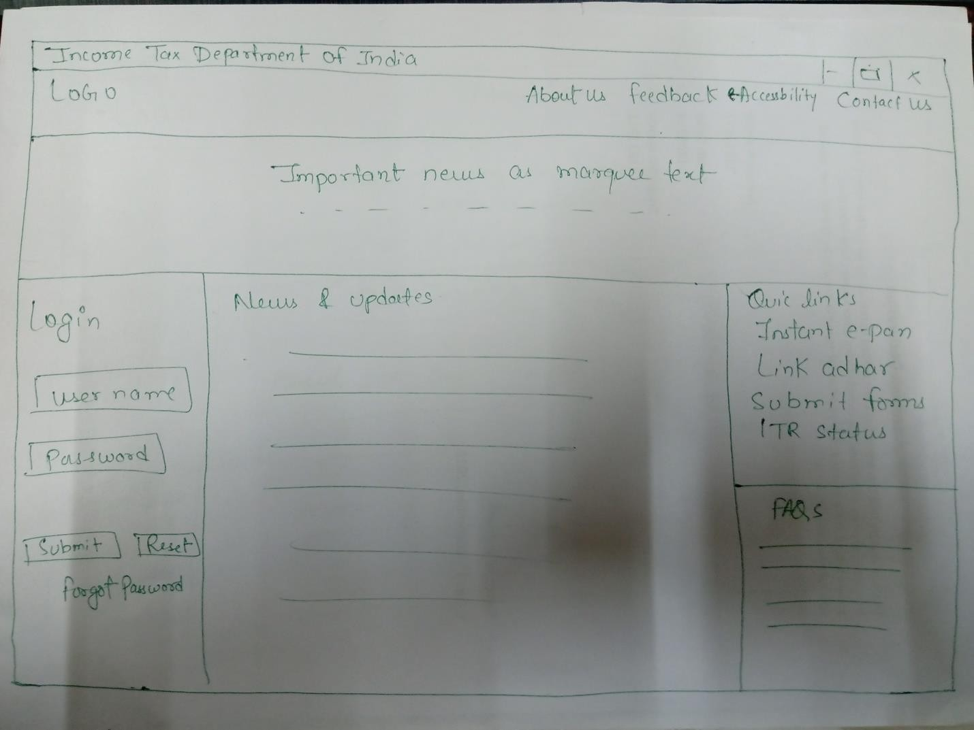Project 15 **Income tax department of India**